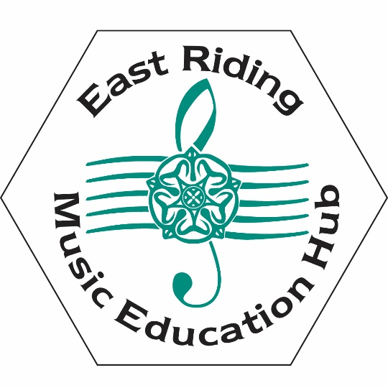
Toolkit for Music
East Riding Music Education Hub
School :
Date:

Self-evaluation Toolkit
Ofsted and Arts Council England both advocate for schools to develop strong relationships with their local music education hub to assist in the moderation and future support process as part of the Governments National Plan for Music Education (NPME).

This toolkit has been developed by the East Riding Music Hub in consultation with the Music Hub Strategy Board, head teachers, school music teachers and senior advisors.
The key purpose for this self-evaluation document is to establish an authentic internal starting point which reflects the school’s own view of itself; its identification of strengths, issues and the developments and improvements which might be made.
It could be used in conjunction with the schools appraisal policy and when writing departmental development plans. It may also be of benefit should a subject specific Ofsted inspection take place.

Using the Tool Kit
The tool kit has drawn up criteria from a variety of sources including Ofsted Criteria for Music, The National Plan for Music Education and the Ofsted observations about schools own music curriculum drawn from the report “What Hubs Must Do Next”.
We have also used data from our own 2014 music curriculum audit (available on the red bag) as guidance.
There may well be criteria listed in the audit tool that schools and academies feel are not appropriate for them at this time. Equally there may be additional criteria that a school wishes to use to articulate particular strengths and/or pertinent development areas. Schools will determine their priorities for improvement.
However if a school chooses to use this audit tool, the principal focus should always be on improving pupils’ musical progress, attainment and achievements.
The tool kit provides the starting point for an internal dialogue between the senior management/governors of the school and the music team/coordinator. The judgements made can then inform the development plan for music within the school.
Members of the Music Hub are available for help and support in either the completion of the tool kit, verifying the judgements or providing support for any outcomes identified as requiring improvement.
How to Fill in the Tables
The example below shows how you may wish complete the tables:

Quality of the Music Curriculum
Area | Evidence | Agreed Comments/Actions
A broad and balanced music curriculum available to all year groups, is in place. | - Music timetabled for Yr 7, 9 and GCSE.  - Current curriculum covers National Curriculum for Music criteria for years taught | - No music taught in Year8. Commitment by senior management to timetable Year 8 music by next academic year.  - Year 8 scheme of work to be developed
Listening, performing, composing, improvising and appraising are carefully integrated in the curriculum, for example, instrumental playing and singing are an integral part of the creative process of composing and improvising. | - Evidenced in lesson observations for year 9 but not year 7  - No regular singing evidenced | - Year 7 curriculum to be rewritten to include more practical learning (by next term)  - Regular opportunities to sing as part of the lesson to be developed (contact music hub for details of singing strategy)

Assessment Toolkit

Quality of the Music Curriculum
Area | Evidence | Agreed Comments/Actions
A broad and balanced music curriculum available to all key stages is in place.
Listening, performing, composing, improvising and appraising are carefully integrated in the curriculum, for example, instrumental playing and singing are an integral part of the creative process of composing and improvising.

The curriculum is well resourced (including the use of ICT) incorporating the opportunity for pupils to compose, perform and appraise
There is a wide range of extra- curricular opportunities available for pupils of all abilities
High quality singing is a key component of the curriculum
Additional instrumental and vocal learning is available to all pupils regardless of their ability to pay i.e. remissions are available for pupils on FSM, LAC or those on working tax credit.

Quality of Leadership and Management of the Subject
Area | Evidence | Agreed Comments/Actions
Subject leaders have a good understanding of the subject, demonstrated through their teaching | - E.G. Music Coordinator, through observations, demonstrates a high degree of expertise and subject knowledge. | - Music Coordinator to work with non-specialist teacher in Year 3
Senior managers have a commitment to developing music in the school and clearly demonstrate an understanding of the unique features in teaching and learning in music, through their lesson observations.
There is a governor linked to music

There is a commitment to CPD for music staff and non-specialists e.g. attendance at network meetings, national conference, hub CPD
Subject leaders engage with a variety of partners and organisations, including the music hub, to satisfy the needs of pupils of all abilities.

There is an up to date school policy and Subject Development Plan for music which sets out its vision and how it supports and contributes to the school’s values and ethos.
Music makes a significant contribution to the whole school ethos
The place of music in the school in terms of its relationship with other areas of learning in and out of the curriculum, is well established.

Quality of Teaching and Learning
Area | Evidence | Agreed Comments/Actions
Music lessons are well planned to have a clear and simple musical focus in each. Long, medium and short term planning is carried out. Cross-curricular links are developed | - E.G. Implementation of Model Music Curriculum in KS2 | - Scheme of Learning for KS1 to be implemented by September 2019
Music lessons are structured so that music making is the predominate feature of the lesson , either through performance, composition or listening
Lessons are challenging and set high expectations so that pupils of all abilities are able to make progress
Notation, in various forms, is used regularly as part of music learning and in a way that supports learning rather than drives it.
Pupils can relate their work to that of professional musicians and it draws on a wide range of historical, social and cultural traditions using a range of resources, including new technologies to support learning

Singing for a variety of purposes forms a regular part of the lessons e.g. to internalise, perform and help pupils understand musical form
A range of teaching strategies are used to enable pupils to develop independently, in groups and as a whole class. Peer learning and development forms part of most lessons.
Clear assessment criteria are employed as part of an overarching assessment policy for music.
Pupils understand how they are being assessed and this is used as a tool to aid progression.
Opportunities for self- assessment and reflection are evident in most lessons.

Partnerships
Area | Evidence | Agreed Comments/Actions
There are good links with the local Music Hub with activities such as whole class instrumental lessons, access to network meetings, attendance at Big Sings/ NYMAZ workshops, sign posting for pupils to other hub activities and out of school ensembles etc. reflected in music department activity. | E.G. Hosted Big Sing 2019; Attended Noise Academy 2018; composition project, performed at Hornsea Festival 2019 | - Senior management to agree time to attend Music Network meetings  - Create register of pupils attending out of school activities
The school works in partnership with other schools and key organisations such as the local Music Service and Music Education Hub to share knowledge, good practice, resources and learning opportunities

Young performers are encouraged to attend music provision outside school such as Music Centres, Community Bands and County Ensembles

The school makes good use of visiting professional musicians and artists to inspire and support learning and pupils’ experiences; performances are also attended

Music Timetable (please fill in as appropriate)
Key Stage | Periods/Lessons per week | Specialist or non-specialist teacher | Other details e.g. on carousel, Arts Awards, Examination course

Planning Check List

Document | Please Tick
Music department development plan

Schemes of work
Assessment information and pupil tracking
Notational and written work by children
Recordings of students’ work
Evidence of concerts, productions, community events
Knowledge of numbers having instrumental lessons both in and out of school; attending music centres; informal learning; gender split
Stakeholders views (parents, pupils, governors etc)
Extra-Curricular Activity
Group/Workshops | Numbers involved | Achievements/Concerts

Summary Judgements
Summary Statement

Area | Score | Evidence | Agreed Comments/Actions
Quality of Music Curriculum
Quality of Leadership and Management
Quality of Teaching and Learning
Partnerships
Overall contribution to the school
Pupil Participation Figures
Score Key
1 = fully in place, highly effective in driving good or better outcomes for pupils, a real strength which our school would be willing to share with others
2 = in place, effective in driving good outcomes for pupils, a strength of music in our school; some development may be required to maintain momentum or make further improvement
3 = working towards, not yet fully in place, further development required, not yet sure of impact on outcomes, needing some support
4 = not in place at all, needs priority support and development
Further Support
The East Riding Music Education Hub can offer a range of support through its partners and Music Service, acting as Lead Organisation for the hub. This may include access to CPD; workshops; Charanga Music School; one to one visits; access to cluster projects; visits from local and national professional organisations and artists.
Our work is highlighted in the termly Hub magazine where you can also find contact details of all our partners.
If you have any immediate support needs contact you Area Relationship Manager or:
Emma Calvert (Head of Schools’ Music Service) at emma.calvert@eastriding.gov.uk

